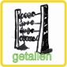

NUMBERS

Information
War was also being waged at sea. The threats came from all angles: ranging from airplanes in the air, from battleships and sea mines on the water and from submarines under water. A battle between war ships is called a naval battle.
The game is called battleships…

Battleships
During battleships, it is the intention to discover the situation of your opponent’s fleet. This is done by aiming your radar at the fleet of your opponent.
To start this game, you first have to place your proper fleet on the sea. You can opt for a horizontal, vertical or diagonal display, as long as your ships do not touch each other. Every ship stands for a word from your vocabulary.

Fleet: a series of ships
Radar: device to discover the situation of ships
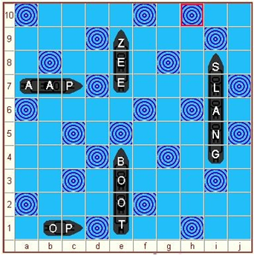
Horizontal:
Vertical:

Diagonal: 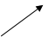

Co-ordinates: letter and number determining
the situation of a ship.

Your opponent has placed his/her fleet on the sea, the game can begin!
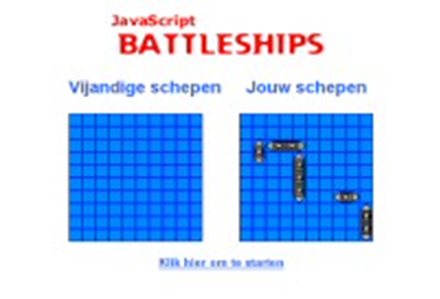

• You now have two playing fields. The left side is the sea area with the ships of your opponent, which is temporarily empty. The right side is your proper sea area, where you can see where your fleet is situated.
• You can aim your radar in turns. This is rather simple: choose the co-ordinates on which you wish to aim your radar, e.g. E 8.
If you have scored a direct hit, your opponent will have to tell you the letter which you have obtained in your focus. Put this letter on the appropriate place on the empty playing field (the sea of your opponent). You may continue asking questions!
If you have scored a miss, please indicate a cross on the appropriate place on the empty playing field. It is now the turn of your opponent to play.
• Your opponent determines his/her co-ordinates and you have to check on your proper playing field whether he/she has scored a direct hit or a miss. He/she will continue to ask questions when striking a direct hit or – in case of a miss – it is once again your turn to have a new try.
The game continues until one of you both knows the situation of all the ships (words) of his/her opponent, however…

In order to prove that you know the word in your opponent’s ships, you have to carry out an additional assignment, for instance:
….* you hand the picture belonging to that word.
….* you make a sentence containing that word

The youngest children can play this game in an easier version: The ships are hiding pictures
The co-ordinates are colors and forms.

11
10
9
8
7
6
5
4
3
2
1
 | a | b | c | d | e | f | g | h | i | j | k

