JOINTLY

Information

Genuine famine and thirst are unknown to us. The choice of food supplies in supermarkets is endless and our refrigerator is filled to the brim. We can eat and drink whatever we like.

At the commemoration of 100 years of ‘Great War’ it is worthwhile to think about the famine which our ancestors had to face from 1914 until 1918. Four years long, they managed to survive on a one-sided diet, and had to satisfy themselves with potatoes and soup. A chicken leg was a mere luxury and was often replaced by chicken blood and onion snippets. The wealthy bourgeoisie supplied themselves on the black market, but had to pay a fortune to get meat and dairy products. The working class depended on charity. Food generated envy, and the farmers were hated because they asked extortionate prices for their products. Following the war, eight out of ten Belgian citizens had to tighten the waist belt because they had lost considerable weight.

The under mentioned link contains recipes of war dishes. These recipes were copied from the ‘War Cook Book’, published by Meulenhoff Amsterdam. In its introduction, we can find the following quote:
‘Simple manual to prepare tasty, nutritious meals and vegetarian dishes with readily available food articles, based on the practical experience of a housewife’.
http://www.wereldoorlog1914.nl/kookboek/

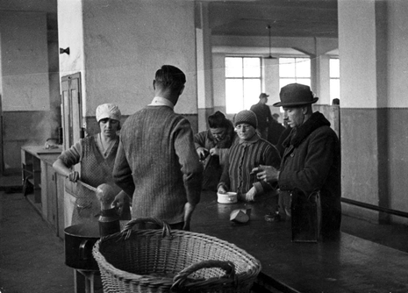

Assignment

Select a dish and prepare it for yourself and your classmates.
That day, you will jointly eat a genuine war dish.

• How does it taste ?
• Would you like to eat this every day ?
• Is this healthy ? Which products do you need to remain healthy ?
