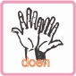 | DO IT

Information

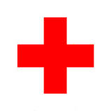
During the war, many doctors and nurses were part of the medical service at the front line to care for the wounded. A red cross on a white surface means that help is given to victims. This symbol was agreed by over 40 countries prior to the First World War. Nowadays, the Red Cross is the largest help rendering organization in the world.

Bandages and bandaging techniques

First aid makes use of quite some bandages. Plasters and swaddles are the most frequent. We will tell you when and how to use them. This can be done by a game of demonstration and imitation.

WHAT DO YOU NEED ?

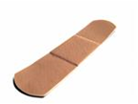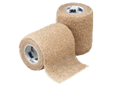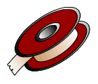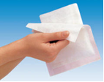

COPY ME
1. Look for a friend to work together.
2. Watch closely what the teacher is doing
3. Your friend is hurt and you display the bandage in the appropriate way
4. Switch the roles
5. http://www.youtube.com/watch?v=SSjjZQnMc-M

