NATURE

Information
The no man’s land between the trenches has been ruffled and is entirely littered with rubble, corpses and wrecks. Scarlet poppies are growing between the debris. Poppies have become the symbol of the First World War.

In Flanders fields
(lieutenant-colonel John McCrae, 1872-1918)

In Flanders fields the poppies blow
Between the crosses, row on row
That mark our place; and in the sky
The larks, still bravely singing, fly
Scarce heard amidst the guns below.
We are the dead. Short days ago
We lived felt dawn, saw sunset glow
Loved, and were loved, and now we lie
In Flanders fields.
Take up our quarrel with the foe:
To you from failing hands we throw
The torch; be yours to hold it high.
If ye break faith with us to die
We shall not sleep, though poppies grow
In Flanders fields

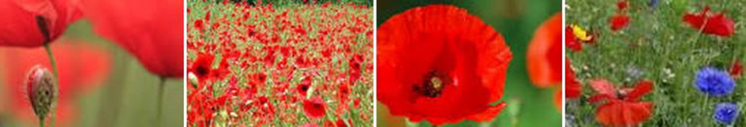

Poppies are growing if other plants are dead. Poppy seeds can lie on the ground for years and only start to grow if other nearby plants and bushes have vanished, for instance if the ground is ruffled and contaminated. Most poppies can be observed in places where construction debris is lying on the ground.
Evidently, the ground surrounding the trenches during the First World War were duly ‘ruffled’ and contaminated by the violent combats and bombardments. McCrae must therefore have seen hundreds of poppies when he wrote the poem in 1915.
But the poppies also have a different meaning in ‘In Flanders fields’. Some poppies are used to make opium and morphine; morphine is a strong anesthetic which was often used to ease the pain of wounded soldiers – sometimes forever. The last verses ‘we shall not sleep, though poppies grow / In Flanders fields’ refer to the stupefying effects of morphine.
Furthermore, the flower has a symbolic meaning: the petals are red like the blood from the fallen soldiers, and the inside is black, the color of mourning.

Assignment

Make a poppy

http://www.youtube.com/watch?v=Zz9PRxBlyDU

