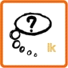

REFLECT

Information

During the war, millions of people escaped for the violence. Many refugees went to the coast, hoping to find a ship that would take them along. They waited on the beach and built cabins made of straw, rags and planks.

Sometimes, also soldiers fled. They did no longer want to fight. A military man who no longer wanted to fight, was punished by his own army.

In order to stop refugees, a fence of live barbed wire was constructed along the border: the Wire of Death.

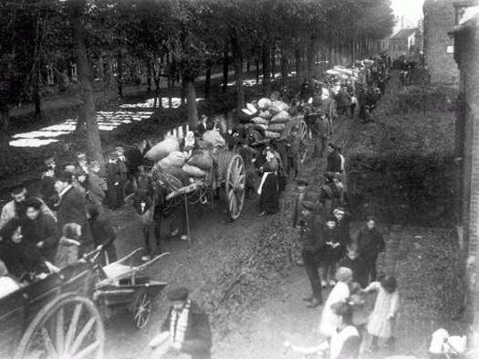

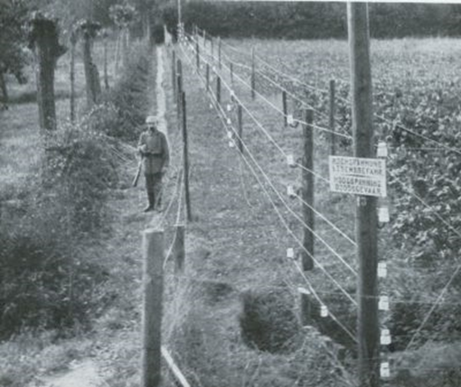

Adults, children,… people like you and me have to make choices during the war, whether they want or not. One of these choices is: do we stay or do we run away?

Listen to the teacher and imagine for yourself what you would do. It does not involve giving a correct or wrong answer. It is important to think about why you are making this particular choice.

Organization:
• Everyone is standing at one side of a line, with yet another line at the other end.
• The teacher describes a situation.
• Think for 1 minute and decide for yourself: What would I do? Do I stay or do I run away? Why?
• The teacher gives a signal. If you opt to run away, go to the line at the other end.
Those who want to stay, remain on the spot.
• Tell why you intended to run away or why you want to stay.
Please bear in mind the following:
You can entirely disagree with others, even with your best friends. There is nothing wrong about that. Do not attack anyone personally.

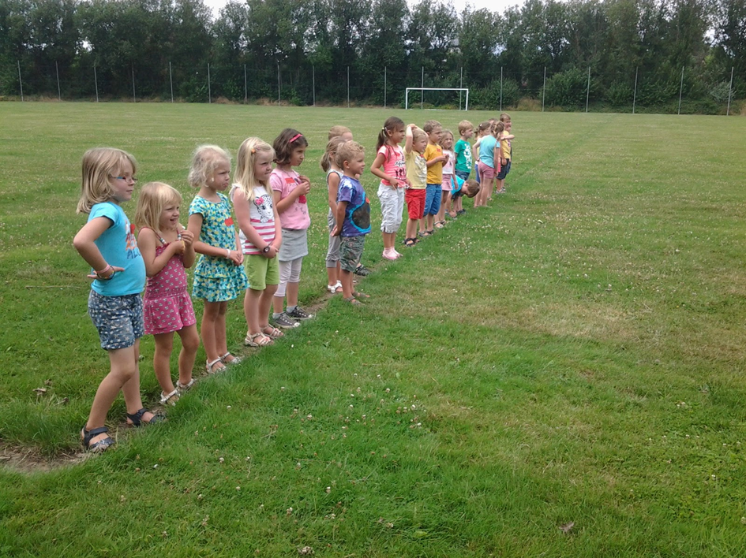

Reflection items

• You are summoned to participate in the great war. Tomorrow, you are expected to report at the town hall. Do you stay or do you flee?
• The great war is breaking loose. There is hardly any food left. Do you stay and try to find whatever food is left in order to survive, or do you flee to another place that you do not know yet?
• You are a soldier in the great war and you are asked to look where other soldiers are hiding themselves. Do you do your utmost and do you try to come nearby? Or do you prefer to keep it safe and do you maintain your distance?
• You are a farmer. All people are hungry and want to buy your milk. Do you charge a fair price or do you make the milk extremely expensive to become rich?
• You work for a newspaper and can only make positive reports about the war. Thus, others will be tempted to join the war. Do you do follow your bosses’ instructions? Or do you honestly tell the truth and report about the horror of the trenches?
• You are a soldier and are admitted in the medical ward for an injury. You are practically cured. Do you try to convince the doctor that you are still in pain? Or do you tell the truth?
• You are in charge of a country. Somebody asks your assistance in the war against his enemy. Do you engage your country in this conflict or do you keep it aloof?
• Your best friend-soldier gets injured. Do you return to bring him into safety? Or do run away as fast as possible to remain out of harm’s way?

